Brittany Sheffield
17 April 2019 | IA 250
Botswana: Prosperity Undermined by Social discontent

Table of Contents
About this Document 2
Key Findings 3
Intelligence Collection Plan 5
Indicator Analysis 8
Link Analysis 10
Geospatial Analysis 11
Analysis of Competing Hypotheses 13
Multi-Criteria Decision Matrix 14
Appendix 1 15
Appendix 2 16
Appendix 3 17
Appendix 4 18
Appendix 5 23
References 24

About this Document
Requirements
This document contains an assessment of the stability of Botswana in the next 12 to 18 months, conducted as part of a long-term country study. In addition, and based on the conclusion, further analysis determined the best course of action for the investment of USD 100 million into the country. The course of action proposed promotes further stability in the country, over the time period previously noted. The analytic methods employed to come to this conclusion were Indicator Analysis, Link Analysis, Geospatial Analysis, Analysis of Competing Hypotheses, and Multi-Criteria Decision Matrix Analysis. The Intelligence Collection Plan organized sources referenced in pursuit of this analysis.
Terms
Analytical Confidence: the statement used to clarify the analyst’s assumptions, gaps of knowledge, and limitations in order to convey to the decision-maker the level of uncertainty associated with any given analysis
Limitations
The analyst conducting this analysis is an undergraduate student studying intelligence analysis, with little subject matter expertise and a novice standing as a practitioner. The student held responsibilities in addition to the research, analysis, and writing of this country-study. Time constraints based on other classwork, limited devoted class-time, and the 15-week period of the semester limited the depth and breadth of knowledge. Finally, the analyst used Open Source Intelligence (OSINT) in the assessment of the country’s stability.
Analytical Confidence
There is a moderate level of confidence in this conclusion, based on the number and quality of OSINT sources utilized, as well as the limited assumptions and opportunity for denial and deception.

Key Findings

Botswana: Prosperity Undermined by Social Discontent

Executive Summary
Botswana is likely to remain stable in the next twelve to eighteen months due to the lack of political corruption, free and open democracy, and the continued growth of the economy. The country holds periodical general elections, both at a national and local level. The main sources of revenue for the country come from the vast tourism industry and the profitable mining sector. However, social unrest based on lack of employment opportunities and the prevalence of water disparity could threaten the continued stability of the country.
Elections within the country rank at the top of African countries, in reference to amount of corruption. Multiple parties exists within the nation; however, opposition parties to the Botswana Democratic Party (BDP), such as the Umbrella for Democratic Change (UDC), recently gained more support from citizens. In the 2014 elections, the UDC won the largest majority of Parliamentary seats of any opposition party. The party increases popular support through a platform focused on diversification of the economy and creation of jobs.
The country’s economy relies heavily on its natural resources, including tourism of indigenous animals and landscape, as well as multiple mineral deposits. Large urban areas and population hubs center around areas of economic performance, such as the game reserves and mines. These industries rely on the environment, while also damaging the resources beyond sustainable levels. Mines currently utilize underground water resources for production, surpassing the recharge rate of these aquifers. The government prioritizes middle to higher income and population dense areas when distributing remaining potable water. Inadequate management in response to the increased demand in urban areas leads to food shortages, and disrupts business, health, and education programs. These factors, in addition to the high youth unemployment within the country, increases the risk of social unrest that would compromise the stability of Botswana.
The investment of USD 100 million into water allocation, treatment, and distribution services could combat the risk of civil unrest and the influence of China in the country. China provides scholarships for students to study abroad, rather than continuing education within Botswana. The implementation of improved water management resources will not only lower the level of education disruption for youth, but also provide job opportunities and economic diversity. This course of action decreases the need for Chinese investment into youth programs and key infrastructure and the country’s influence in Botswana. The creation of improved education systems and more jobs lower the possibility of social unrest and support continued stability within the country.

Intelligence Collection Plan
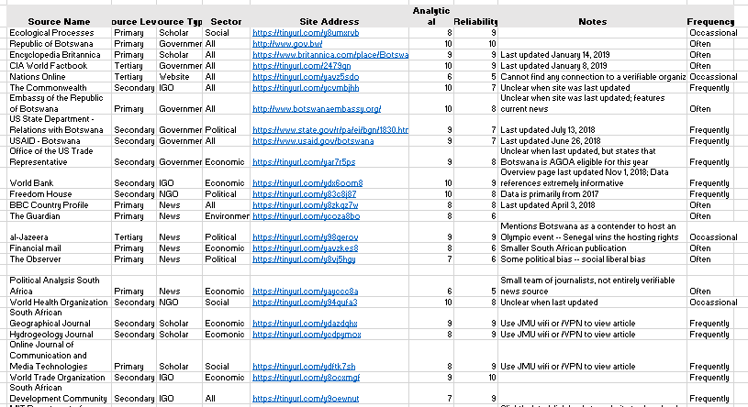
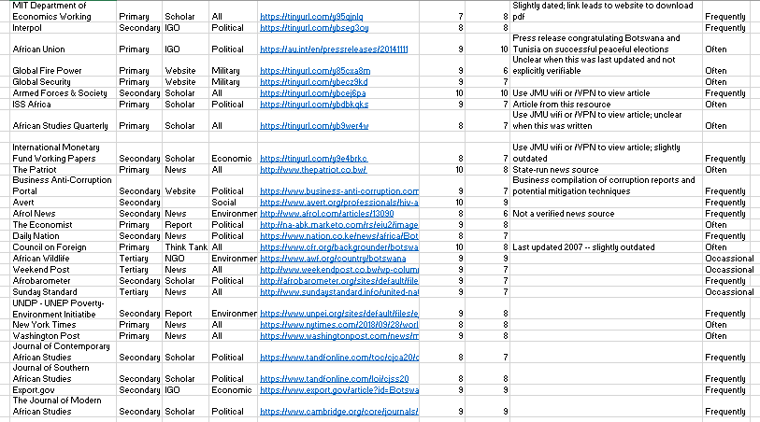
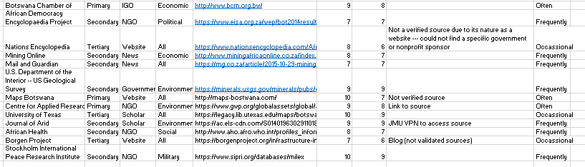

Indicator Analysis
Botswanan Socioeconomic Growth Faltering
Executive Summary
Stagnation of previously positive social and economic trends within Botswana present opportunity for citizen discontent and cancellation of further growth. Funding for HIV/AIDS and awareness campaigns declined in recent years. Current trends highlight reduced human rights and unfavorable economic conditions for citizens.

Discussion
Botswana has the third highest HIV/AIDS prevalence rate in the world, despite the rate decreasing from 25 percent in 2005 to 23 percent in 2018. Additionally, over 95 percent of individuals in need of anti-HIV treatments receive them, a number that indicates movement towards the Joint United Nations Programme on HIV/AIDS (UNAIDS) 90-90-90 targets., Due to this success, as well as the country’s classification as an upper-middle income country, foundations now provide less funding. The National AIDS Coordinating Agency (NACA) estimates that the cost of response to the crisis will increase from USD 274 million to USD 339 million by 2030. An additional setback includes the implementation of mandatory testing, a measure that is unfavorable among the community (see Appendix 1).
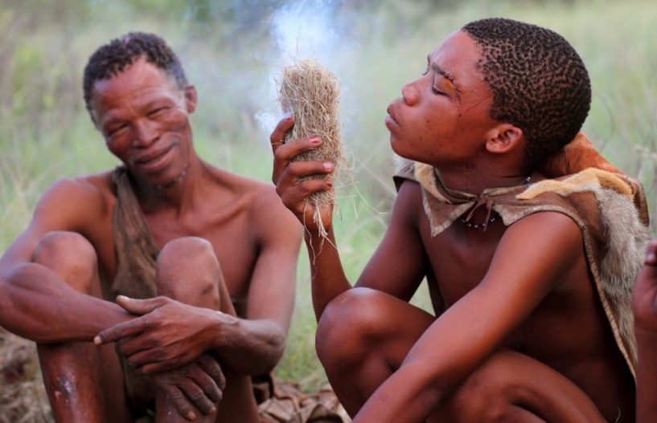
Botswana recently announced the closure of refugee camps and the removal of refugees from Namibia and Zimbabwe. Many Zimbabwean refugees returned home after years of asylum in the country. Defence, Justice and Security Secretary, Shaw Kgathi, announced the closure of a Namibian refugee camp, a decision facing high criticism from human rights groups as a violation of international law., Domestically, Botswanan Bushmen face removal and relocation into government created resettlement camps (see Figure 1). Government reasoning highlights the need for natural resource and ecosystem management, while Bushmen and human rights groups suggest government interest in diamond and mining reserves.
Figure 1 Bushmen of Botswana | http://tinyurl.com/y64rwkbd
Unemployment in Botswana from 1991-2017 averages at 19 percent. However, the youth unemployment (ages 15 to 35) increased to 25 percent in recent years, with females as the most impacted group. The government faces criticism from citizens and larger global groups based on its unsatisfactory efforts at job creation, as well as the lack of efforts combating unemployment and economic stagnation.

Link Analysis
Political and Mining Power Control Botswana
Executive Summary
The incumbent political party and mining companies hold high authority within the country, although voting power increases the influence of citizens. The Botswana Democratic Party (BDP) works closely with Debswana to implement economic policies that support mining. The Umbrella for Democratic Change (UDC) is a coalition of parties that provides an alternative to BDP for citizens, through a focus on placating concerns surrounding the lack of economic diversity.
Discussion
The BDP, the ruling party since Botswana’s independence in 1966, faces a faltering level of support with the rise of competition. The UDC provides an alternative for citizens to consider when voting in general elections. In the most recent general election of 2014, the BDP won 65 percent of seats in Parliament,, and the UDC won 30 percent, increasing their influence within the government. Support of urban citizens shifted towards the UDC, which inhibited the strength of the BDP within the country and government.
Mining companies in Botswana hold power to influence political decisions. As the public rating of the nation’s economy increases, the government is more likely to increase investment into the industry (see Appendix 2). While industry makes up 27 percent of Botswana’s GDP, the industrial production growth rate for 2017 showed a decline of four percent.
Citizens discontented with the current economic and political performance shift preference according to the options that best serve them. In the most recent election, the UDC ran on a platform addressing a “growing, resilient, and diversified economy.” The low GDP per capita associated with the mining industry combined with the growing discontent over the youth unemployment rate increases the citizen displeasure and desire for change seen in the 2014 elections.

Geospatial Analysis
Impacts of Botswanan Dependence on Environment
Executive Summary
Botswana’s economic dependence on natural resources to generate Gross Domestic Product (GDP) leads to environmental degradation that could potentially affect key industries and the citizens. The country relies primarily on mining and tourism to support the economy. Consequences that stem from this reliance effects the standard of living within the nation.
Discussion
Botswana relies on natural resources as a source of economic production. Many cities center around the various mines and resources prevalent in the country (see Appendix 3). Diamond exports encompassed 85 percent of exports in the first nine months of 2014. Population density focuses around large mines, including cities such as Gaborone and Francistown. Officials expect growth of the sector due to increased production at two mines. Industry generates 27 percent of GDP composition, and services such as tourism account for an additional 71 percent. The government designated approximately 18 percent of land in the country as national parks. These parks contain campsites and offer a diverse location for many of the safari companies that operate in the country.
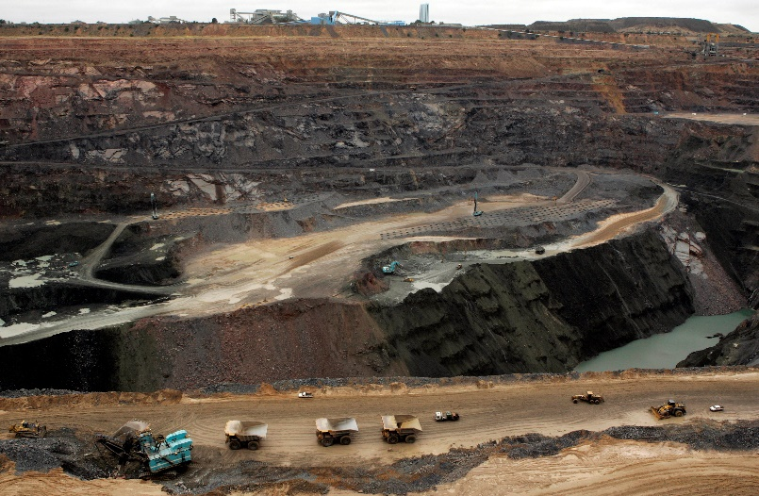
Botswana’s reliance on natural resources increases the negative impact on the environment (see Figure 2). The mining sector relies on underground water; currently, the rate of use surpasses the recharge rates and sustainable levels of these aquifers. A study conducted in neighboring Zambia identified levels of mercury, lead, nickel, and copper from a river near a prominent mining area. This provides an example of the potential impact in Botswana, where there is an absence of dedicated studies. Tourism also contributes to environmental problems within Botswana. Increased traffic from tourism requires the creation of illegal road systems and causes higher levels of noise pollution. Additionally, greater numbers of tourists in areas such as the Okavango Delta lead to elevated levels of waste, which strains the sewage system and further impacts the water resources.
Figure 2 Example of Environmental Degradation Caused by Major Botswanan Mines | http://tinyurl.com/yxlmeos4

Analysis of Competing Hypotheses
Positive Economic and Democratic Trends Sustainable Factors for Stability
Executive Summary
Botswana is likely to remain stable for the next twelve to eighteen months due its open democracy and economic progress. The country’s lack of corruption in public office, free and consistent elections, and economic growth support continued sustainability. However, instability is more likely if unemployment related social unrest were to erupt.
Discussion
Botswana ranks 34th out of 180 countries in corruption levels, one of the highest in Africa. In addition to this, the country holds local elections simultaneously with general elections. Citizens elect 57 members of the main governmental body, the National Assembly. This body then selects the president to a five-year term following the general elections. The structure of elections and government created provides citizens equal opportunity to participate and hold power.
The country experienced an average of five percent growth over the last decade, as the economy continues to expand. The largest sector that contributes to this success is diamond mining, which accounts for one third of government revenue. In addition, Botswana holds preferential trade status with the United States through the African Growth and Opportunity Act, renewed through 2025. Economic progress and trade with large global partners underscore the likely tract of stability within the country.
Despite positive trends within Botswana leading toward continued stability, the potential for social unrest could possibly call this stability into question within the next twelve to eighteen months (see Appendix 4). Citizens between the ages of 15 and 29 make up one-third of the population. The unemployment rate for this demographic is approximately 25 percent. Youth fail to foster skills and qualities in their education to become hirable, and the government minimally supports this demographic. Without policies to combat the rising issue of youth unemployment, social unrest and instability becomes more likely.

Multi-Criteria Decision Matrix
Infrastructure for Clean Water Access Likely to Combat Chinese Influence
Executive Summary
Investing USD 100 million into increased water recovery efficiency, sanitation, and distribution technologies will likely support continued prosperity and diminish the influence of China in Botswana. The reliance of both the mining and agriculture industries on underground water requires more than aquifers can renew naturally. Access to clean water fluctuates between urban and rural populations. Additionally, updating water delivery systems requires the renovation of key infrastructure.
Discussion
The country has vast underground water stores; however, costs, low yields, poor quality, and distance from population centers limits the retrievable amount. The mining and agriculture sectors rates of use exceed the sustainable levels of underground water sources. Additionally, Botswana cannot build more dams due to the country’s terrain, and those currently in use primarily function as water storage.
The country’s urban areas receive better allocation of water resources and access to clean water. As demand for water in urban areas increases, inadequate water management leads to food shortages and disruption of business, health, and education services. Additionally, settlement size determines the allocation of water sanitation systems, with prioritization of larger and upper income areas.
Chinese companies profit from the implementation of major building projects, such as dams, railroads, roadways, airports, and other key infrastructure., China also provides scholarship and training opportunities for Botswanan students in China. The investment in water conservation, allocation, and sanitation infrastructure will combat the disruption of educational experiences for students, and provide further employment opportunities within the country, decreasing the impact of Chinese strategies (see Appendix 5).

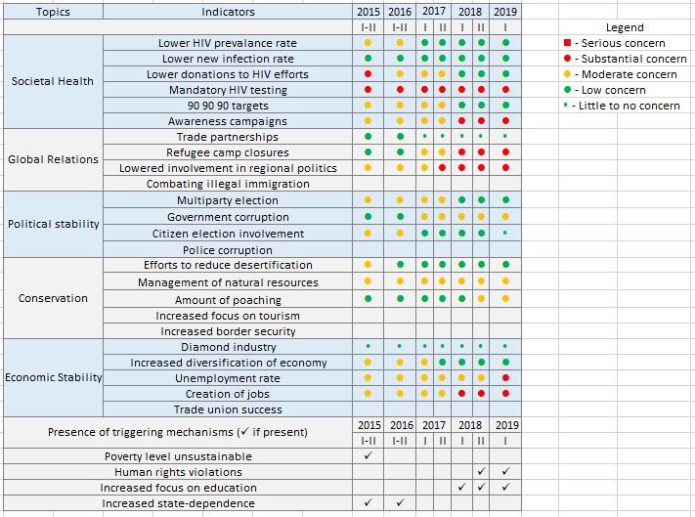
Appendix 1

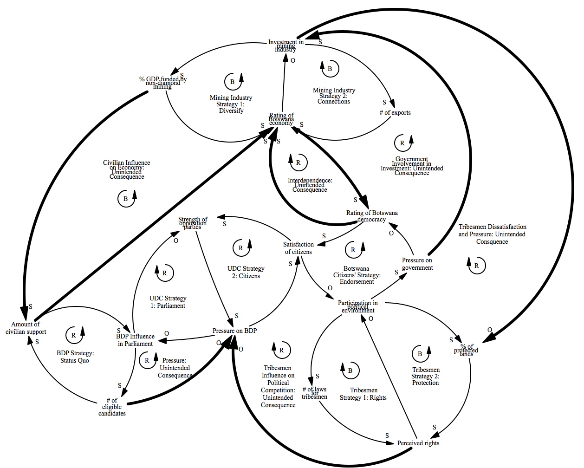
Appendix 2

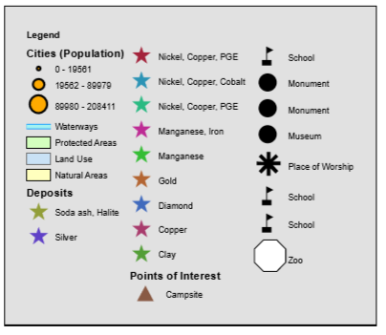
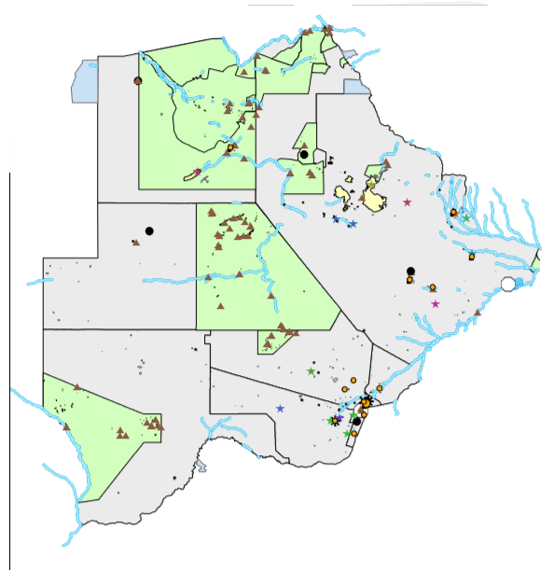
Appendix 3

Appendix 4
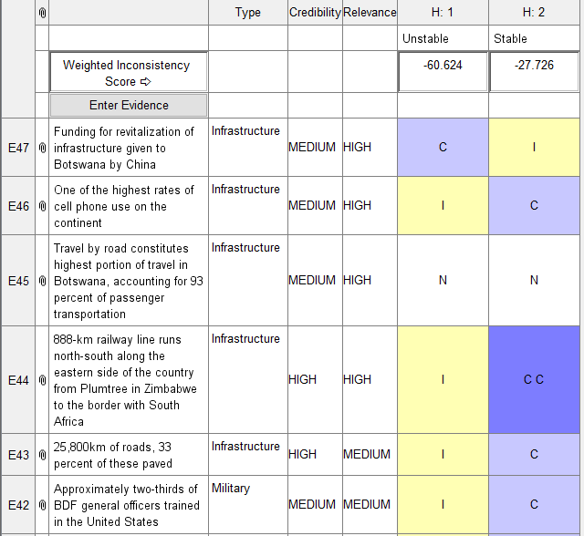
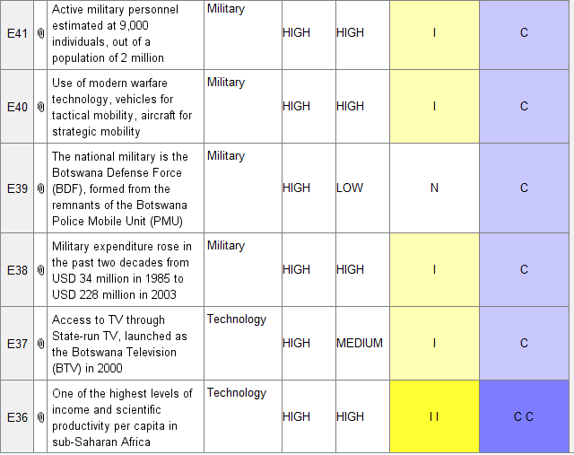
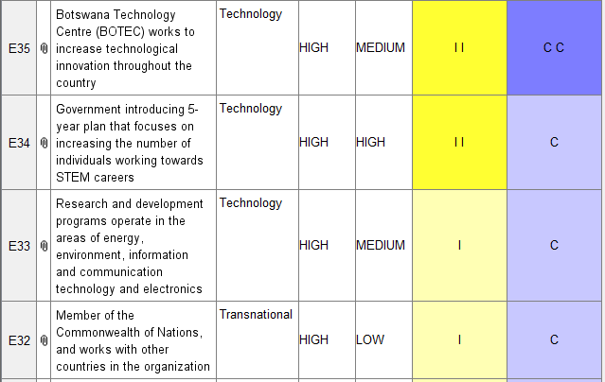

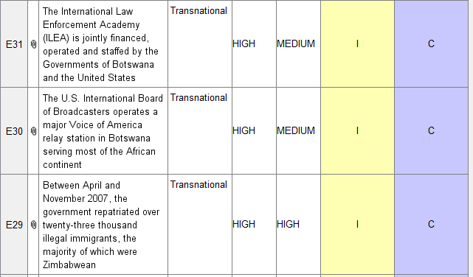

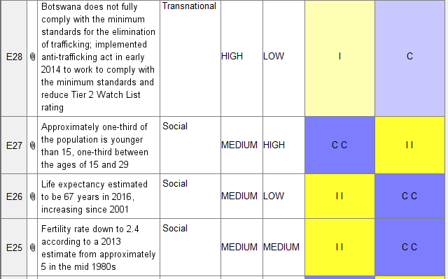

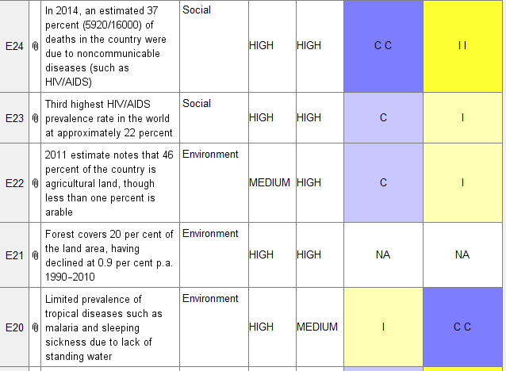

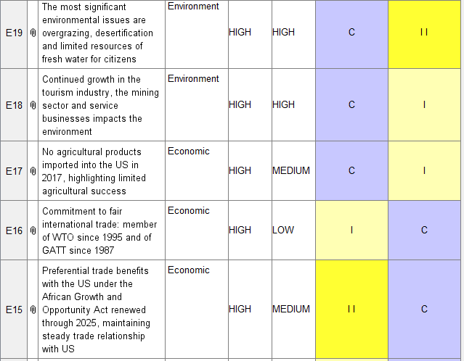

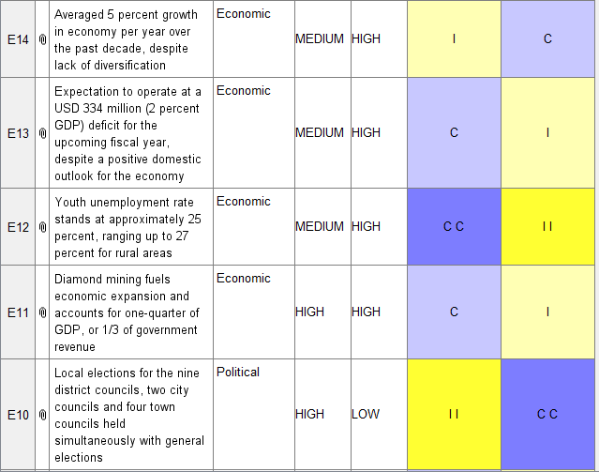

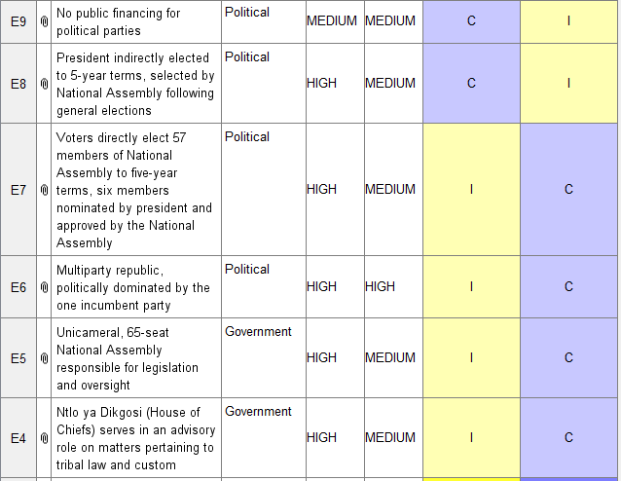

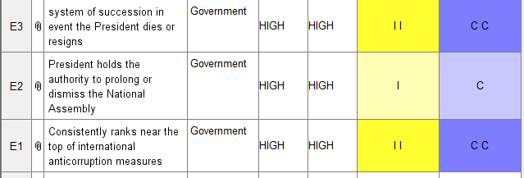

Appendix 5

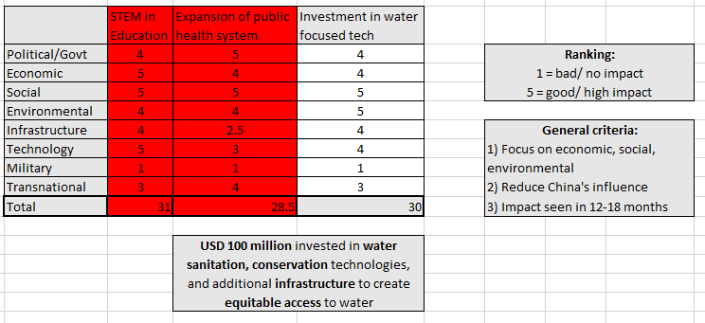

References

“Botswana: An African Success Story Shows Strains,” Council on Foreign Relations, accessed April 11, 2019, https://www.cfr.org/backgrounder/botswana-african-success-story-shows-strains.
“Botswana,” Freedom House, Freedom in the World 2018, January 4, 2018, https://freedomhouse.org/report/freedom-world/2018/botswana.
“EISA Botswana: 2014 National Assembly Election Results,” accessed February 10, 2019, https://www.eisa.org.za/wep/bot2014results.htm.
“Water Policy Brief: Reflecting on the Challenges of Attaining a Green Economy for Botswana” (United Nations Development Programme, 2012), https://sustainabledevelopment.un.org/content/documents/1007National%20Report%20(Water)%20-%20Botswana.pdf.
“Water Policy Brief: Reflecting on the Challenges of Attaining a Green Economy for Botswana.”
Kabelo Adamson, “Youth Unemployment Rate Stands at 25%,” The Voice, January 22, 2019, https://thevoicebw.com/youth-unemployment-rate-stands-at-25/.
“HIV and AIDS in Botswana,” AVERT, December 2018, https://www.avert.org/professionals/hiv-around-world/sub-saharan-africa/botswana.
“Ending AIDS: Progress Towards the 90-90-90 Targets,” Global AIDS Update (Joint United Nations Programme on HIV/AIDS (UNAIDS), 2017), http://www.unaids.org/sites/default/files/media_asset/Global_AIDS_update_2017_en.pdf.
Lindy Davies, “Population in Africa: Whirlwind, or Just Spin?,” Progress, January 27, 2019, https://www.progress.org/articles/population-in-africa-whirlwind-or-just-spin.
“Progress Report of the National Response to the 2011 Declaration of Commitments on HIV and AIDS” (National AIDS Coordinating Agency, June 2015), http://www.unaids.org/sites/default/files/country/documents/BWA_narrative_report_2015.pdf.
“Botswana’s Draconian Public Health Bill Approved by Parliament, BONELA Will Challenge It as Unconstitutional Once President Signs into Law (Update 3) | HIV Justice,” accessed January 29, 2019, http://www.hivjustice.net/news/botswanas-public-health-bills-hiv-related-provisions-counter-productive-discriminatory-unconstitutional-and-barbaric/.
Xaxa (Shasha), “Zimbabwean Refugees Return Home From Botswana,” Pindula News, January 12, 2019, https://news.pindula.co.zw/2019/01/12/zimbabwean-refugees-return-home-from-botswana/.
Xaxa (Shasha).
Arnaldo Vieira, “Botswana’s Quit Notice to Refugees,” Daily Nation, May 17, 2018, https://www.nation.co.ke/news/africa/Botswana-quit-notice-to-refugees/1066-4566862-xh3pxo/index.html.
“NamRights Lashes out at Botswana for ‘cruel Treatment of Refugees,’” Political Analysis South Africa, January 7, 2019, https://www.politicalanalysis.co.za/namrights-lashes-out-at-botswana-for-cruel-treatment-of-refugees/.
Pumza Fihlani, “Botswana Bushmen: Modern Life Is Destroying Us,” BBC News, January 7, 2014, sec. Africa, https://www.bbc.com/news/world-africa-24821867.
“Botswana Unemployment Rate,” Trading Economics, 2019, https://tradingeconomics.com/botswana/unemployment-rate.
Kabelo Adamson, “Youth Unemployment Rate Stands at 25%,” The Voice, January 22, 2019, https://thevoicebw.com/youth-unemployment-rate-stands-at-25/.
“Sunday Standard - Online Edition,” October 24, 2014, https://web.archive.org/web/20141024172509/http://www.sundaystandard.info/article.php?NewsID=20411&GroupID=1.
“EISA Botswana: 2014 National Assembly Election Results,” accessed February 10, 2019, https://www.eisa.org.za/wep/bot2014results.htm.
“Botswana’s Ruling Democratic Party Wins General Elections - BBC News,” accessed February 10, 2019, https://www.bbc.com/news/world-africa-29776097.
“EISA Botswana: 2014 National Assembly Election Results.”
“Botswana Economy: Population, GDP, Inflation, Business, Trade, FDI, Corruption,” accessed March 25, 2019, //www.heritage.org/index/country/botswana.
“Africa :: Botswana — The World Factbook - Central Intelligence Agency,” accessed February 10, 2019, https://www.cia.gov/library/publications/the-world-factbook/geos/bc.html.
“Udc-Gabs-South-Issues.pdf,” accessed February 10, 2019, http://www.electionsbotswana.org/article/udc-gabs-south-issues.pdf.
Thomas R. Yager, “The Mineral Industry of Botswana,” 2014 Minerals Yearbook (Botswana: United States Geological Survey, December 2017), https://minerals.usgs.gov/minerals/pubs/country/2014/myb3-2014-bc.pdf.
“Debswana Diamond Mines,” Mining Technology (blog), accessed February 20, 2019, https://www.mining-technology.com/projects/debswana/.
Yager, “The Mineral Industry of Botswana.”
“Africa :: Botswana — The World Factbook - Central Intelligence Agency,” accessed February 14, 2019, https://www.cia.gov/library/publications/the-world-factbook/geos/bc.html.
“Environment - Botswana - Problem, Farming,” Nations Encyclopedia, accessed February 21, 2019, https://www.nationsencyclopedia.com/Africa/Botswana-ENVIRONMENT.html.
“Safari Companies - Botswana Travel Guide,” accessed February 21, 2019, http://www.botswana-travel-guide.com/bradt_guide.asp?bradt=931.
“Water Policy Brief: Reflecting on the Challenges of Attaining a Green Economy for Botswana” (United Nations Development Programme, 2012), https://sustainabledevelopment.un.org/content/documents/1007National%20Report%20(Water)%20-%20Botswana.pdf.
Michael B. Kwesi Darkoh, “Socio-Economic and Environmental Impacts of Mining in Botswana: A Case Study of the Selebi-Phikwe Copper-Nickel Mine” (University of Botswana, January 2015).
Joseph E Mbaiwa, “The Socio-Economic and Environmental Impacts of Tourism Development on the Okavango Delta, North-Western Botswana,” Journal of Arid Environments 54, no. 2 (June 2003): 447–67.
Mbaiwa.
“Corruption Perceptions Index 2018,” Transparency International, Index 2018, 2018, https://www.transparency.org/cpi2018.
“Botswana : Constitution and Politics,” The Commonwealth, accessed March 20, 2019, http://thecommonwealth.org/our-member-countries/botswana/constitution-politics.
“Botswana,” Freedom House, Freedom in the World 2018, January 4, 2018, https://freedomhouse.org/report/freedom-world/2018/botswana.
Neil Parsons, “Botswana,” in Encyclopedia Britannica, March 18, 2019, https://www.britannica.com/place/Botswana.
“Botswana: Overview,” Text/HTML, World Bank, accessed March 21, 2019, http://www.worldbank.org/en/country/botswana/overview.
“Africa :: Botswana — The World Factbook - Central Intelligence Agency,” CIA World Factbook, January 23, 2019, https://www.cia.gov/library/publications/the-world-factbook/geos/bc.html.
“Botswana,” U.S. Department of State, accessed March 21, 2019, http://www.state.gov/r/pa/ei/bgn/1830.htm.
Parsons, “Botswana.”
Kabelo Adamson, “Youth Unemployment Rate Stands at 25%,” The Voice, January 22, 2019, https://thevoicebw.com/youth-unemployment-rate-stands-at-25/.
Correspondent, “Collaborating to Tackle Youth Unemployment,” Mmegi Online, March 8, 2019, http://www.mmegi.bw/index.php?aid=79953&dir=2019/march/08.
“Botswana Integrated Water Resources Management & Water Efficiency Plan” (Gaborone, Botswana: Department of Water Affairs - Ministry of Minerals, Energy & Water, May 2013), https://www.gwp.org/globalassets/global/activities/impact-stories/further-reading/iwrm-we-plan.pdf.
“Water Policy Brief: Reflecting on the Challenges of Attaining a Green Economy for Botswana” (United Nations Development Programme, 2012), https://sustainabledevelopment.un.org/content/documents/1007National%20Report%20(Water)%20-%20Botswana.pdf.
“Botswana Integrated Water Resources Management & Water Efficiency Plan.”
“Water Policy Brief: Reflecting on the Challenges of Attaining a Green Economy for Botswana.”
“Water Policy Brief: Reflecting on the Challenges of Attaining a Green Economy for Botswana.”
“China’s African Ambitions Stumble in Botswana | News | Al Jazeera,” accessed March 31, 2019, https://www.aljazeera.com/news/africa/2014/08/chinas-african-ambitions-stumble-botswana-201482312611222505.html.
Anna Ying Chen, “China’s Role in Infrastructure Development in Botswana,” no. 44 (n.d.): 20.
“An Overview of the Relations Between China and Botswana,” accessed April 4, 2019, http://bw.china-embassy.org/eng/sbgx/t404979.htm.

